GITRA (Glasgow Implementation Tool for Restorative Approaches)

- GITRA was developed following discussion and requests from establishments for support around the implementation of RA.
- It is based on Thorsborne and Blood (2013) implementation framework for RA. Following feedback from user reference groups, some of the steps have been simplified and the language modified so that it more appropriate for the Glasgow context.
- GITRA has been created using Powerpoint. It is an interactive tool and allows users to be able to navigate through the program using hyperlinks and also allows users to enter and store their own data/information. The images below are screenshots taken from the programme and provide an overview of what GITRA looks like.
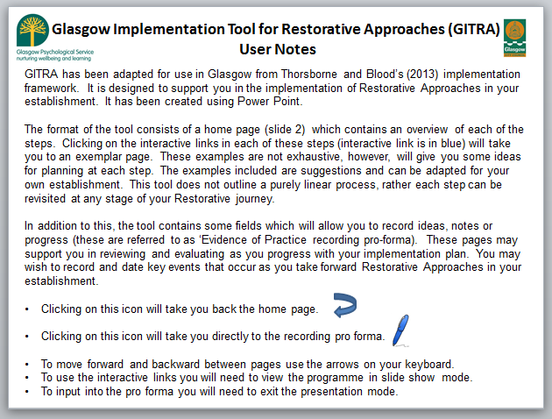
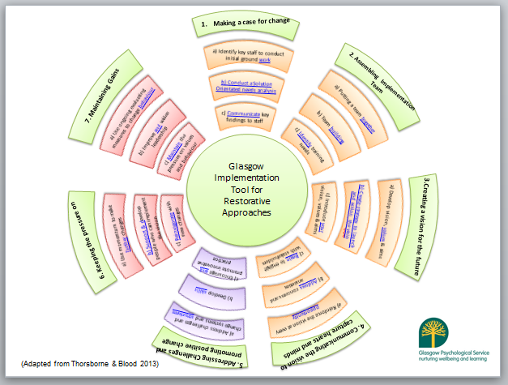

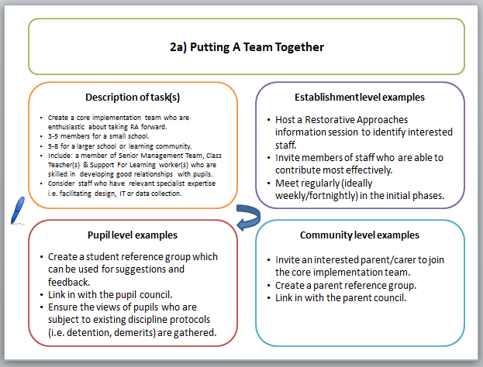
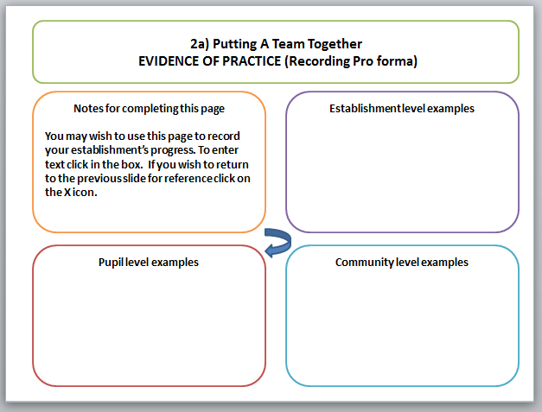

- GITRA will be provided to schools electronically and can be saved on e.g. a USB Pen Drive, CD or emailed as a ZIP file. The electronic pack includes the GITRA interactive framework, the RA readiness booklet and other resources such as question cards, posters etc.

Implementation of GITRA

- GITRA is being piloted in 4 establishments at present. These establishments are all at different stages in their RA journey. The establishments are:
  - Glendale Primary (South)
  - High Park Primary (North East)
  - Drummore Primary (North West)
  - Bannerman High ( North East)

- These schools have agreed to provide formal feedback with regards to their use of GITRA. Feedback will be gathered via focus groups scheduled to take place in May 2017.

- It is hypothesised that some changes to GITRA may be required following feedback from focus groups. If these are required then the program will be modified and then made available on request.

- Once GITRA is made available more widely further guidance/information for EPs will also be provided to allow them to support establishments following a request.

